**Project Overview**

**Yingtong Zhou**

1. Functionality

Develop an app to keep track of daily stock transactions and profits. The user will input stock name, shares, average cost, net value, investment amount (Entries to be decided), and the program will calculate the return by a bunch of formulas, show win and loss PL, tell you the win/loss percentage, and graph the results at the front end.

Advanced function (if applicable): include APIs to import the trade directly from the brokerage

1. UI Design

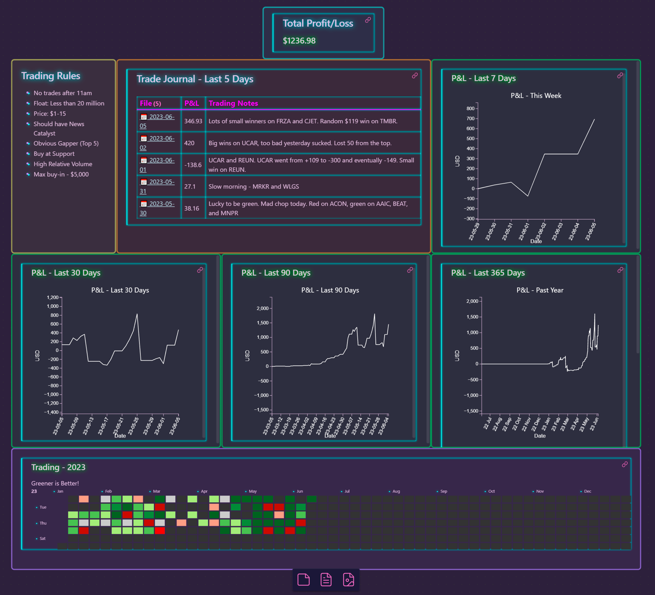

Output:

line graph: matplotlib

trade notes: recorded by users

total PL: every time user inputs modified/automatically

brokerage: drop-down menu

time range shift

wins/loses: green toggle sort algo

progress bar: user set goal

connect API

flying shit (loss money) & dancing charging bull (win/开屏)

<https://zhuanlan.zhihu.com/p/509602009>